Exercise-13
13. ReactJS-HOL

Create a React App named “bloggerapp” in with 3 components.
1.Book Details 2.Blog Details 3.Course Details
Implement this with as many ways possible of Conditional Rendering.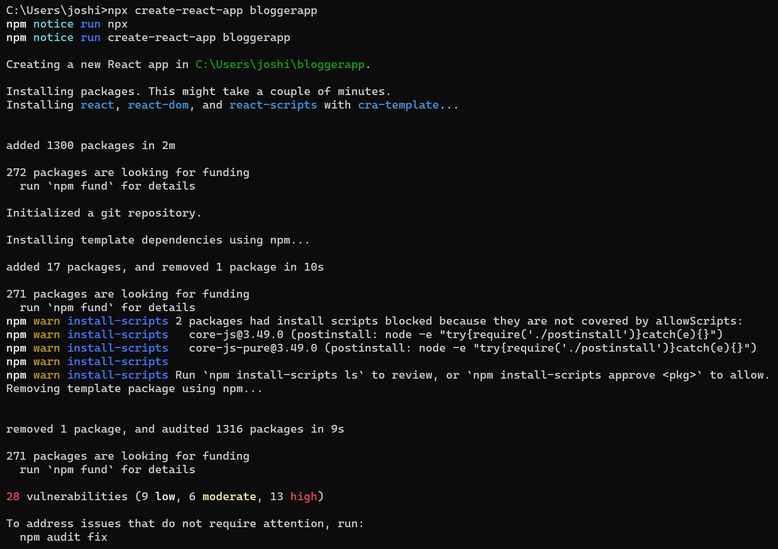 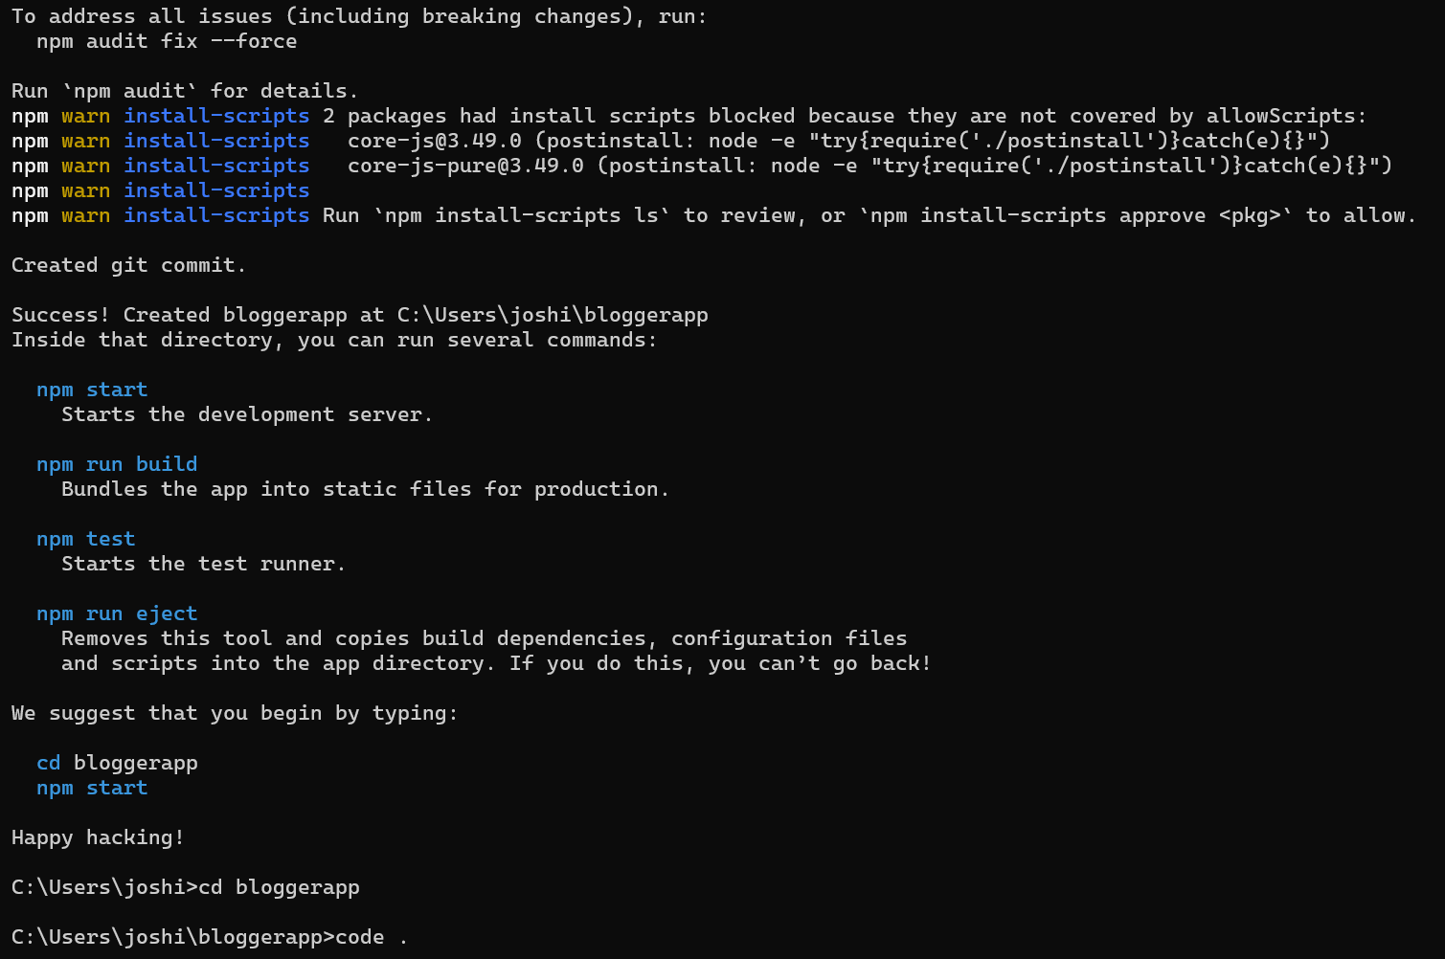
App.js:
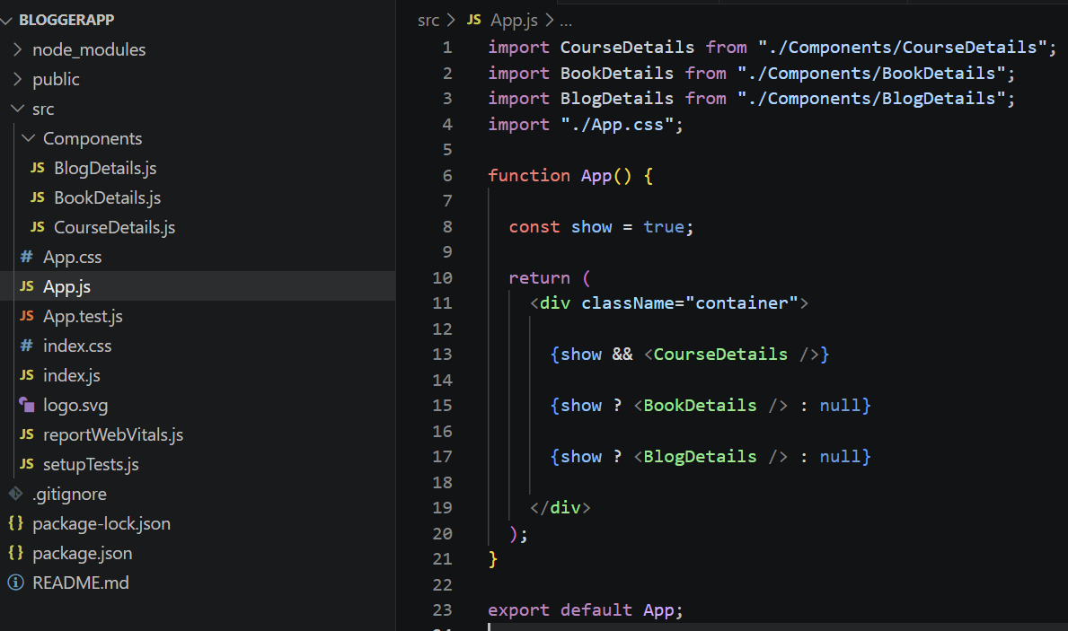

App.css:
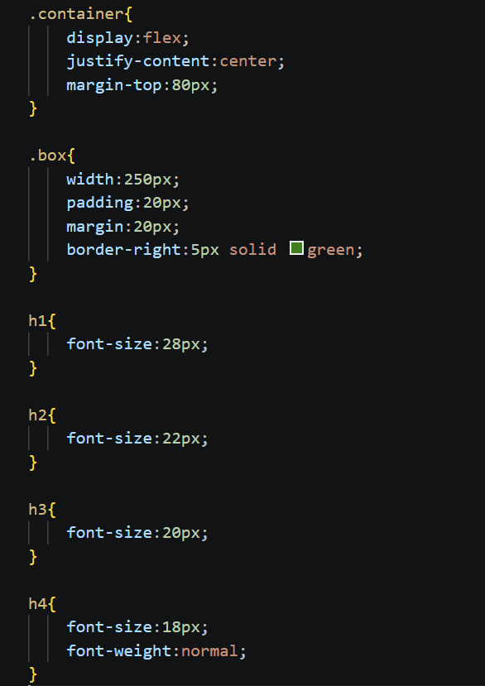
BookDetails.js:
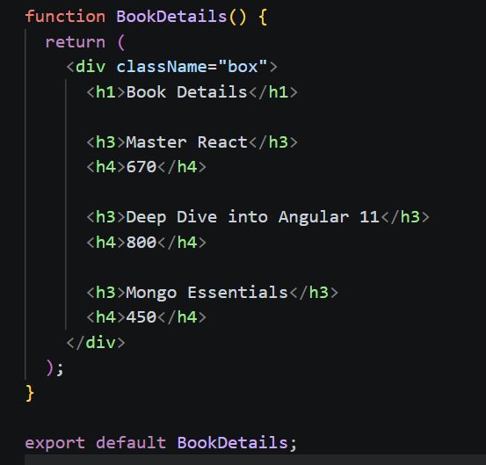
BlogDetails.js:
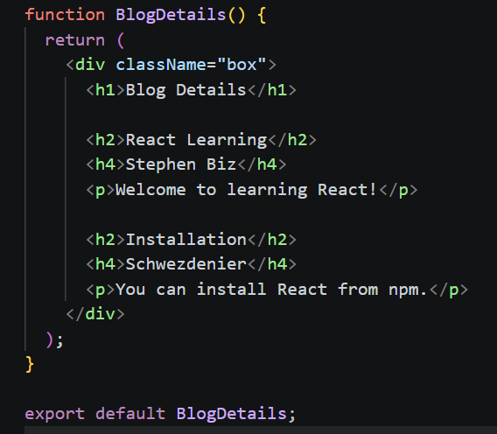
CourseDetails.js:
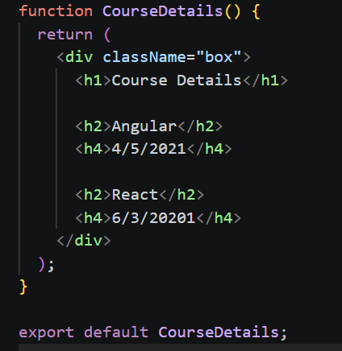
OUTPUT:
